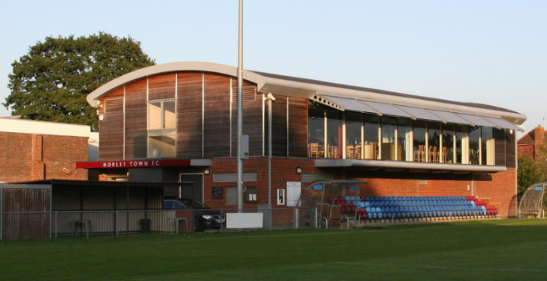
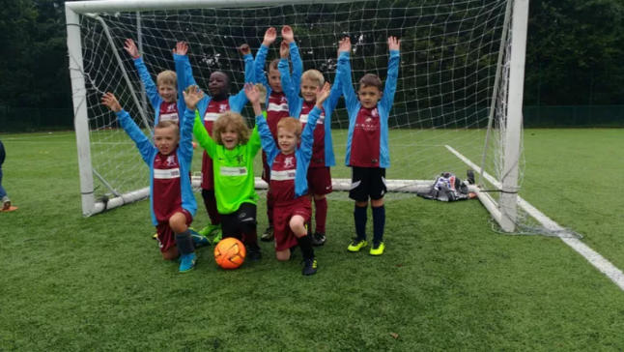
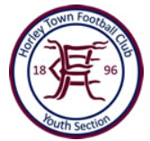

Horley Town FC Youth
U7-U11 Annual Summer Festival 2023

Sat 13th May: U7s (AM) & U9s (PM)
Sun 14th May: U8s (AM), U10s & U11s (PM)
*Please note this event excludes academies, schools of excellence & representative sides*

Dear Club Secretaries/Coaches,

After an amazing weekend of tournament football last May, when even the weather was very kind to us, we are once again delighted to invite you and your teams to our popular Annual Summer Festival for U7 to U11 teams. This year, the event will take place on the 13th and 14th of May.

The format will be the same as our previous events, and please find below some basic details, and what to expect on the day: -

- Teams can be mixed boys/girls, max squad size for the day is 10 players
- For those with larger squads, you are welcome to register more than one team
- Age groups you enter are based on the current 2022/23 season
- U7’s and U8’s will play 5-a-side with all players receiving a medal at the end of the session
- Under 9s to U11’s will play 6-a-side and play through to a final for a trophy presentation
- Where possible we will keep teams from the same club apart when we draw the groups
- The rules will be explained on the day and sanctioned by Surrey FA
- The entry cost per team is £40 (non-refundable unless the event is cancelled by HTFC)
- Spaces are allocated on a first come basis upon receipt of your payment
- Payment can be made via Bank Transfer or Cheque (sent to the location address below)
- Entry on the day is £2 per family, (incl. parking and programme) - coaches get free entry
- Food and refreshments will be available all day, and our bar is open during licenced hours
- Closing application date of Friday 31st March 2023
If you have any further questions, please email us at horleytownfcjuniors@gmail.com

To enter your teams, please complete the simple booking form on the next page. Payments can be made by bank transfer (Horley Town Football Club, Barclays Bank, 20-23-98, 43826074 - please ensure you include your clubs name/age groups in the reference so we can more easily cross check entries with payments). Alternatively, you can pay by cheque, just send this with your completed form to the address at the bottom of the booking form. Please book early to avoid disappointment, some age groups booked up very quickly last year.

We look forward to another enjoyable festival of football for everyone, and we hope to see you and your teams at Horley Town in May!

Kindest regards,

Horley Town FC Youth Tournament Committee

Horley Town FC Youth
Annual Summer Tournament 2023 – Entry Form

Team Name(s)
Club FA Affiliation No.
Team
Colours
Contact Name(s)
Mobile Number(s)
Contact Email(s)*
*Entries will be confirmed by email, please ensure email address is clear. If for any reason you have not received your final instructions 2 weeks before the tournament, please contact us at horleytownfcjuniors@gmail.com. Refunds will be given for any unsuccessful entries.

Sat 13th May  2023 | No. of Teams Entered** | Sun 14th May  2023 | No. of Teams Entered**
Under 7’s (AM) |  | Under 8’s (AM)
Under 9’s (PM) |  | Under 10s (PM)
 |  | Under 11s (PM)
**if more than one team is entered in an age group, please advise all the team names, colours and contacts

Total No. of Teams: …….……. x £40 per team = £........……….

***Entries close on Friday 31st March 2023 – first come, first served basis***

Note - entry on the day is £2 per family, which includes parking and a programme (coaches get in free). HTFC has a good-sized car park (overflow is the surrounding estate) – anyone parking does so at their own risk, as HTFC will not be held responsible for any loss or damage.

Location: Horley Town FC, The New Defence, Anderson Way, Horley, Surrey, RH6 8SP (note - car park and venue are located behind the Horley Leisure Centre).

Best contact is via email: horleytownfcjuniors@gmail.com For payment queries, contact Nicky Maybury (07753 216403) or for other queries Nick Chadwick (07986 510550)

